Stem cell injection repairs damage to London man's heart after attack
By Peter Carty April 18, 2015 10:54 BST

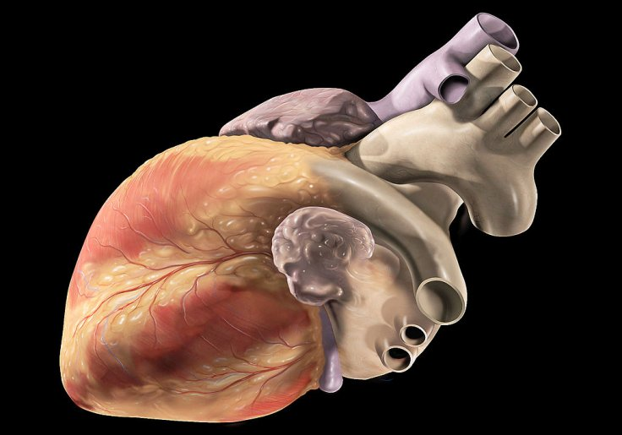
New stem cell treatment for heart attacks is being trialled by Barts
A London family man has become one of the first patients to receive an injection that "heals" damaged hearts.
The prognosis for Owen Palmer, 52, was poor after he suffered a heart attack.
Palmer says that afterwards he was barely able to walk and was unable to climb stairs. "I would just sit in a chair watching TV," he says. Before revolutionary new treatment the outlook was grim: "I had to come to terms with the prospect of not getting better."
Treating the damage to heart tissue caused by cardiac arrests has often involved risky surgery and a lifelong reliance on medication. The new treatment being developed by Barts NHS Trust at the London Chest Hospital uses stem cells.

From hip to heart
First doctors extracted bone marrow from Palmer's hip and separated white blood cells from it. Stem cells were then extracted from the white blood cells, which were injected into his heart muscle. This began a process of tissue regeneration which has now strengthened the muscle considerably.
Palmer, a business strategy director from Woolwich, has said his "life has changed dramatically".
He began the treatment in November 2012 and now fences three times a week, sometimes taking on Commonwealth gold medallists.
"I am the luckiest man alive," he says.
Barts NHS Trust is involved in the world's biggest trial of stem cell therapy for heart attackpatients.
Palmer was one of an early small pilot group to receive the treatment. The first set of results are positive and the trial is now being rolled out to 21 research centres in 11 European countries, and is set to help thousands more patients.
The research is headed by Professor Anthony Mathur, with funding from the Heart Cells Foundation.
The goal in the UK will be to win approval for the treatment for use throughout the NHS.

